Chapter – 2 .
RESEARCH AND DEVELOPMENT THEMES
● INTRODUCTION ● THEMATIC AREAS ● SPECIFIC ISSUES
INTRODUCTION
- Thematic Areas have been developed through consultation with stakeholders and with relevant national policy documents including the National Agricultural Policy 2061, Agri Business Policy 2063, Agro bio- diversity Policy 2063, Bird Rearing Policy 2068 and Gender Main Streaming Strategy of the Ministry of Agricultural Development and other relevant agriculture Policies.
- Within each of the six general themes, the FMC, with advice from the TSC, will indicate specific priorities for each of the calls for applications to the fund.
- The funding from NARDF will follow the Working Procedures of the Fund, and focus on the thematic areas presented in summary form below.
THEMATIC AREAS
1. Enhancing agricultural (Crops, Horticulture, Livestock and Fisheries) production and productivity and improvement of farming systems.
2. Agricultural (Crops, Horticulture, Livestock and Fisheries) research and extension to reflect user-demand and the need to generate additional household income.
3. Climate change adaptation in plant health and animal health for optimizing the production.
4. Sustainable utilization of natural resources and the protection of the resource base and environment.
5. Medicinal and aromatic plants (MAPs), their domestication, production and value addition.
6. Agricultural trade, agribusiness, agro-tourism, agro-processing, food safety, quality control and policy issues.
- Key conditions that govern proposals submitted for NARDF support, within the thematic areas, are:
a. Increased inclusion of small farmers in research and development activities,
b. Increased inclusion of women farmers in the research and development activities,
c. Improved pluralism in agricultural research and development through an increase in joint activities and partnerships.
- The responsibilities for decisions in the development of thematic areas and specific priorities are summarised in Figure 4.
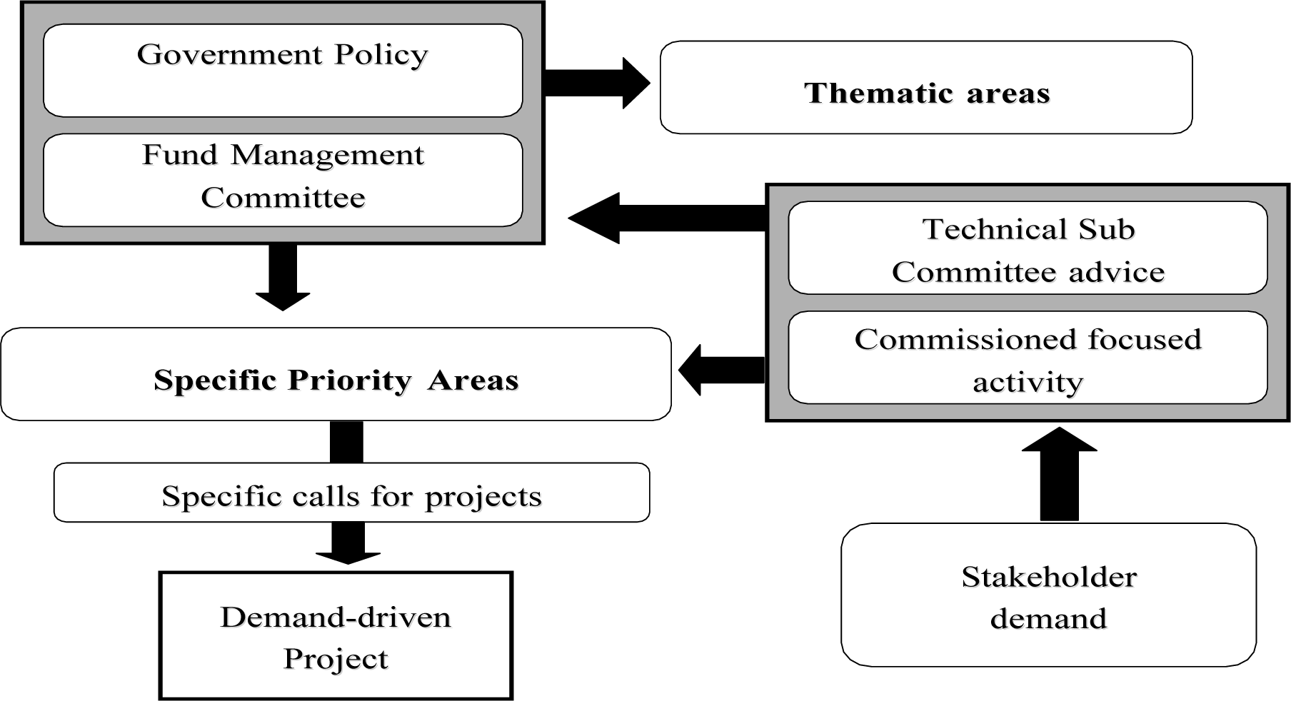
Figure 4: Developments of Thematic Areas and Specific Priorities for NARDF
SPECIFIC ISSUES
Small scale farmers
- The agricultural policy has aimed at ensuring the inclusion of small farmers and women in all aspects of growth. Small scale, marginal and resource-poor farmers and agro-entrepreneurs constitute the majority of the rural community.
- The development and support of markets, marketing and other post- harvest initiatives are an important aspect of NARDF support to activities.
- There is an obligation to address the specific needs of the deprived and marginalized sections of the population. Research and development providers must increasingly re-orient their focus to include these issues in core programs.
- Appropriate indigenous technical knowledge [ITK], traditional practices and locally available resources should be duly considered and tested and utilized in research programs and technology development.
Women Farmers
- It is essential that women farmers become more involved in technology development through on-farm research and training activities.
- NARDF will focuses also on :
a. Women-only projects and projects which are more women focused
b. Mainstreaming of gender within the broader policy framework
Methodologies and partnerships
- Technological development and dissemination need to be sensitive to the conditions of rural women whose contribution is often greater than that of men in production, storage, processing and marketing of crops and livestock products and in the collection, utilization and management of natural resources.
- On-farm and outreach research should be considered the driving force for technology generation and dissemination. This is the process of joint farmer, extension and research work in farmers’ fields to identify problems, develop, implement and evaluate technologies.
- Strengths of on-farm research include, inter alia:
a. Incorporation of ITK into technology generation and dissemination;
b. Re-orientation of on-station research programmers to address farmers’ needs;
c. Better integration of national, regional and farm – level activities;
d. More effective interaction between research – extension – farmer feeding back to appropriate technology generation;
e. Opportunity for researchers to observe farmer uptake of technologies and adapt them to wider usage;
f. Opportunity for constant monitoring and development of new technologies on-farm.
- Priority will be given to research and development topics generated from village level workshops participated by researchers, extension workers, development agencies and farmer groups, and supported by the Regional Technical Working Groups.
- Emphasis will be given to a system based research approach which is multi-disciplinary and multi-commodity, involving multi-actor teams and being participatory in nature.

