Chapter – 10 .
GUIDELINES FOR FINANCIAL MANAGEMENT AND MONITORING
● INTRODUCTION ● PROCEDURES ● FORM AND FORMATS
● FINANCIAL MONITORING ● PROJECT AGREEMENT FORMAT

INTRODUCTION
- As a basic principle, funds are released on the basis of agreed work plans and budgets. The general flow of funds is shown in figure 4.
  - Five forms are used to submit, keep request and account for funding, and are given in full in Annex 7. The preparation and submission of these are linked with the reporting process.
  - Training and guidance can be given by the NARDF Secretariat before implementation if there is any doubt on the correct procedures.
  - Applying institutions especially private institutions, NGOs, CBOs, Co- operatives and Civil societies need to produce firm registration, tax and VAT registration. But this does not apply to GOs. Applying institutions choosing advance payment should present bank guarantee equivalent to the advancement claim with NARDF during implementation of the project.

PROCEDURES
  - The project budget is approved as in the project proposal. In some cases this will be a carefully structured and relatively inflexible budget based on a clear work plan for the full term of the project [blueprint projects]; in others it will be an estimate, based on a firm plan for the first year, with the capacity for amendments based on progress and lessons learned during that and subsequent years [process project]. The research oriented projects will tend to be blueprint projects, whereas farmer research and development and extension projects will tend to be process projects. The type of project will be agreed between NARDF and the applicants during the approval process.
  - The procedures for both are similar, although the process projects require detailed work plans to be developed for each project year, within an overall framework; on the other hand the blueprint projects have clear work plans drawn up from the start of the project, which generally require little alteration during implementation.
  - NARDF has six forms, [see Annex 7 which are used for financial application, reporting and bill issued from the Fund
- FORM 1 – Estimated expenditure for the current trimester, based on the approved budget and work plan
- FORM 2 – Summary of expenditure and income for the current trimester
- FORM 3 – Application for funds for the next trimester
- FORM 4 – Annual financial summary
- FORM 5 – Project completion financial summary
- FORM 6– Bills issued from NARDF in every payment (NARDF internal use only)
  - The aim has been to keep the forms as simple as possible, whilst maintaining the maximum amount of transparency and accountability.
  - The cycle of fund disbursal is shown in Figure 7. As soon as the agreement has been signed between the concerned organization and NARDF, the first release of funds can be made. For this to happen the project must draw up a work plan, based on the project proposal, which indicates the fund requirement for the first trimester [four months]. Forms 1, 2 and 3 are submitted to NARDF Secretariat for checking and approval. However advanced fund only be released upon submission of bank guarantee.
  - Once the forms have been verified, funds are released to the project for implementation.
  - After the first release of funds, Forms 2 and 3 indicate the expenditure incurred by the Project. All expenditure must be fully receipted and recorded, and although these are not required when submitting claims for funding, they must be available for audit purposes.
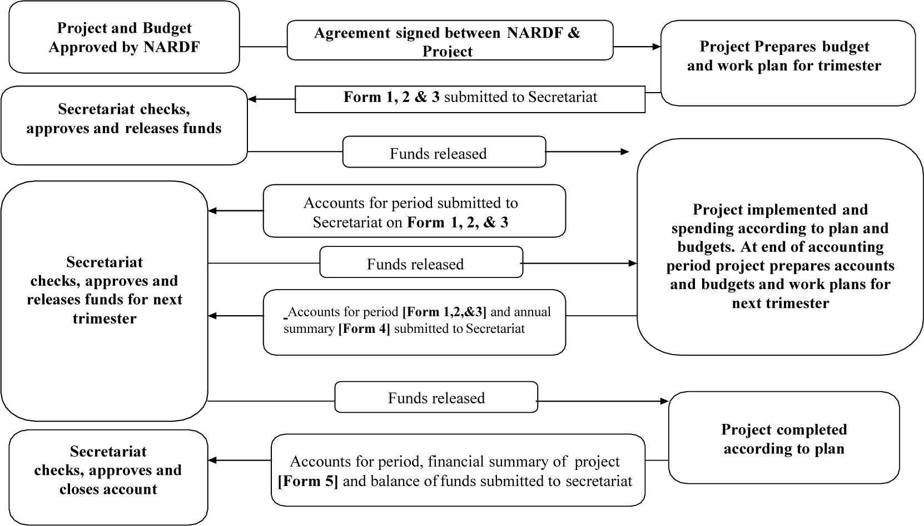

Figure 7 Funding cycle for NARDF projects
- At the end of the fiscal year, an Annual Summary of Finances [Form 4] is submitted to the NARDF secretariat. Form 5 is submitted on project completion.
- The release of funds depends on the accurate completion of the forms as per the accomplishment of planned activities and the successful audit of accounts.

FORMS AND FORMAT
- There are five forms used for financial reporting, of these, one is used at the end of each fiscal year [Form 4] and the other one is only used at project completion [Form 5].
- The format has been kept simple, and it is not necessary to submit vouchers or receipts. These must however, be kept with the Project Co-ordinator and Organization Head, or someone nominated by the organization for inspection by auditors. All the forms have to be signed by the Project Co-ordinator/ Organization Head, undertaking that the figures are true and that expenditure has been according to the agreement of the grant.
- If a project is experiencing financial difficulties, it should contact the NARDF Secretariat at the earliest to review the problems and seek appropriate solutions.
FORM 1 is used to present the expected expenditure for the trimester that funds are being applied for. It is based on the agreed work plans and approved budgets for the project. The layout is shown in Figure 5, and is self-explanatory.
FORM 1. Estimated expenditure for current trimester

Project Reference No:
Project Title:

Fiscal Year: Project Year:
Trimester period covered by expenditure
From: |  | To:
Description |  |  |  | Estimated expenditure
Activity 1
Activity 2
Activity …n
Overheads
Contingency
 |  |  | Total:
Note : Form 1, 2 and 3 for trimester report.
Form 4 for Annual report.
Form 5 for Project Completion report.
Form 6 for NARDF internal only.

FORM 2 shows the current status of finances held with the project, and is a summary of money received and expenditure during the previous trimester.
FORM 2. Expenditure made and income for current trimester
Project Reference No:
Project Title:
Trimester period covered by this summary
From: |  |  |  | To:
Description | 1 Total Budget | 2 Budget Released | 3Proposed  Budget | 4Balance  Forward | 5Funds  received | 6Other  income | 7Expenditure
Activity 1
Activity 2
Activity …n
Sub total [A]
Overhead (Max 12%)
Contingency (3%)
Total [B]
VAT
Grand total [A+B]
8Current
Balance

1 Total Approved Budget
2 Expenditure up to previous trimester
3 Proposed budgets for this trimester
4 The balance brought forward from the previous trimester
5 Funds received from NARDF for the trimester
6 Other income received or generated by the project during the trimester
7 Actual receipted expenditure incurred
8 [Balance forward + Funds Received + Other Income] – Expenditure

FORM 3 is where the information on Form 1 and Form 2 is brought together, and the amount of funding required for the next trimester is given.
FORM 3. Application for NARDF funding for next trimester
Project Reference No:
Project Title:
Trimester period covered by the application for funding
From: | To:
Description |  | Total
1. Balance from previous trimester [Total from Form 2]
2. Funds received [Total from Form 2]
3. Other Income [Total from Form 2]
4. Sub-total [Funds available = 1 + 2 + 3]
5. Expenditure of Current Trimester [Total from Form 2]
6. Current Balance [4 – 5]
7. Estimated expenditure for next trimester [Total from Form 1]
8. Net advance due for next trimester [7 – 6]

Project Coordinator :
Signature:
Chair Person:
Signature:
FORM 4 is completed once a year (Annual) and submitted with the third trimester financial report. It is simply a summary of receipts and expenditure for the year.
FORM 4. Annual financial summaries
Project Reference No:
Project Title:
Project year covered by this summary
From: |  |  |  | To:
Description | 1Total Budget |  | 2Previous expenditure | 3Budget | 4Amount Received | 5Expenditure | 6Balance | 7Note
Activity 1
Activity 2
Activity …n
Sub total
Overheads (max 12%)
Contingency (3%)
Total
VAT
Grand Total
Current Balance

1 Total Approved Budget
2 Previous Year's expenditure
3 Figure from the approved budget for the project year
4 Amount received from NARDF plus any additional income reported
5 Expenditure incurred and reported for this year
6 Amount received [column 4] less expenditure [column 5]
7 Indicate note number and attach on a separate sheet if additional explanation is required
FORM 5 is filled in only once, at the end of the project period. It is submitted with the final annual and final trimester financial reports, along with any balance of funds remaining.
FORM 5. Project Completions Financial Summary
Project Reference No:
Project Title:
Project Period covered by this Project Completion Summary
From: |  |  |  | To:
Activities |  | 1Approved budget |  | 2Expenditure |  | 3Balance | 4Note
1
2
3
Sub Total
Overhead (max 12%)
Contingency (3%)
Total
VAT
Grand Total
1 The figure from the project budget approved by NARDF
2 Expenditure report on Form 4 for each year
3 Balance of budget remaining if any at the end of project
4 Indicate note number and attach notes on a separate sheet if additional explanation is required

FORM 6 is issued from the NARDF in every trimester during the budget release. (NARDF official use)
Form 6. Budget release form
Project Title:
Coordinator | Institution
Project Number : | Funding Source: | Project Start Date:
Total Budget: | Agreement date: | Project Completion date:
Bill no: | Project year: | Trimester:  In NRs.

S. No. | Activities no. | ¹Total Budget | 2Previous release |  | 3Proposed  Budget | 4Expenditure  Proposed | 5Expenditure  approved | 6Forecast | 7Advance  Balance | 8Payment | 9Total Payment (D+K) | 10Budget balance (C-L)
 |  |  | Activities | Advance
A | B | C | D | E | F | G | H | I | J | K | L | M
1
2
3
4
 | Sub total [A]
 | Overhead (max 12%)
 | Contingency (3%)
 | Sub Total [B]
 | VAT
 | Total [A+B]
 | Advance
 | Grand Total
1 Total proposed budget for that activity
2 Total budgets released in previous trimesters
3 Budget proposed for that particular trimester period
4 Expenditure proposed by project for that trimester
5 Expenditure approved by NARDF
6 Forecast for next trimester
7 Balance of budget remaining if any at the end of the trimester
8 Actual payments in this trimester
9 Total payments up to this trimester
10 Budget balance for the listed activities

FINANCIAL MONITORING

Financial Audits
- During the course of the project, the NARDF Secretariat will regularly monitor the financial transaction of the project.
- For auditing purpose, government offices or related institutions should follow the rules of the Public Procurement Act, 2063 (Public Procurement rules, 2064) and other institutions should employ the professional auditors affiliated to the Institute of Chartered Accountants of Nepal.
- All project expenditure records are made available to the auditors. The NARDF Secretariat expects all projects to abide by their institutional accounting rules which must be in accordance with the rules and regulations of Government of Nepal.
- The Auditor's report will be made available to concerned institution/ Organization on completion of the audit. Any deficiencies noted in the report will be expected to be acted upon promptly. Please refer to project agreement clause No. 22 to 26.

