Chapter – 1 .
INTRODUCTION AND ORGANIZATIONAL STRUCTURE
● INTRODUCTION ● ORGANIZATIONAL STRUCTURE ● PANEL OF PEER REVIEWERS ● CODE OF CONDUCT OF PEER REVIEWERS ● SIZE OF FUNDS AND MANAGEMENT ● MONITORING AND REPORTING

This Operating Manual is designed as a guide to the operation of the National Agricultural Research and Development Fund. Further additional information and manuals available online at www.nardf.org.np

INTRODUCTION
- The National Agricultural Research and Development Fund [NARDF] was established by a Cabinet decision on the 10th of December 2001, under Section 3 of the Working Fund Act, 1986. In Exercise of the power conferred by Clause [a] of section [6] of the Cabinet Order to establish the National Agricultural Research and Development Fund 2001 and as provisioned by the Clause [36] of the NARDF working procedure 2015, the FMC has the authority to frame and describe the Manual.
- The Fund is comprised of Budget received from the Government's allocation and other sources approved by the Ministry of Finance.
- NARDF is governed by a seven person Fund Management Committee [FMC] chaired by the Secretary of the Ministry of Agricultural Development. It is administered and operated by the NARDF Secretariat. The head of the Secretariat is the Member Secretary of the FMC. The Secretariat is supported by a Technical Sub Committee and a panel, or list of Peer Reviewers.
- Awards are in the form of partial or full grants to the projects selected through a peer reviewed open competition. The applications for competition should confirm to the agreed formats, criteria and priorities. The objectives of the applicant organization should be relevant to the NARDF thematic area.
- The Fund attempts to involve government, non-government, educational, private sector, civil society, co-operatives and community based Organizations (CBOs) in agricultural research and development through collaboration and partnership.
- NARDF provides grants to innovative agricultural research and development projects that support to the defined national objectives and priorities and deliver measurable outputs within a three-year period. These objectives and priorities are clearly articulated in NARDF's own priority and thematic areas published with the call for project concept notes and proposals.
ORGANIZATIONAL STRUCTURE
- NARDF structure, responsibilities and summary of functions are shown in Fig.1
- The membership and conditions of service for the Fund Management Committee are given in the Cabinet Order which established the NARDF.
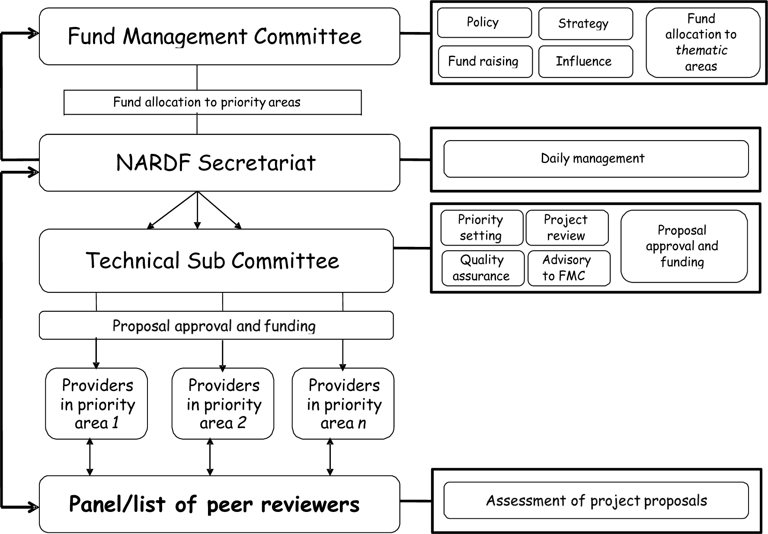
Figure 1: Structure and Responsibilities of NARDF
- The FMC has responsibility for guiding the fund, and is accountable to funding sources and other stakeholders [Figure 2]. It decides on overall policy and strategy, and the allocation of funding envelopes for priority areas.
- Funding Envelopes - These are blocks of money, allocated by the FMC according to NARDF strategic priorities which are determined by Government policy, and advice from the Technical Sub Committee as well as at the interest of research buyers.
- Priority areas - Within the funding envelopes and thematic areas [see Chapter 2], the specific priorities can vary according to circumstances and which will be described in detail during each call for proposals. Thematic areas and priorities are as reflected in national policy.
- Organizations providing funds to NARDF sign a memorandum of understanding [MoU] and may decide their own priority areas for which funds are to be used.
- The FMC raises funds from government, the private sector, donors, development banks and others.
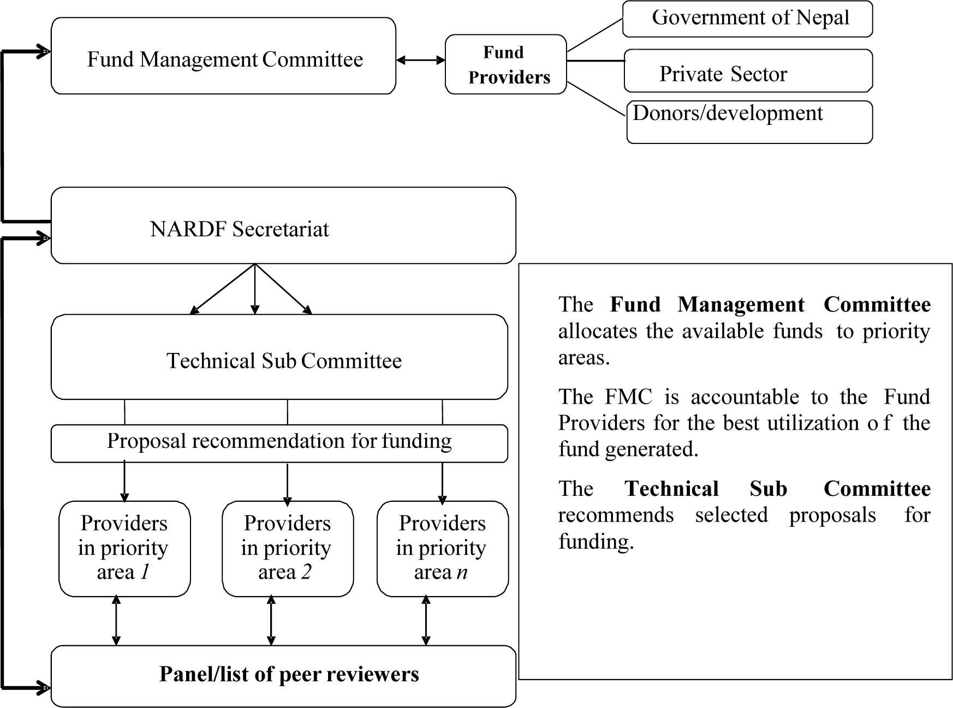
Figure 2: NARDF responsibilities and accountability
- The NARDF Secretariat is headed by the Member Secretary of the FMC. Staffs are appointed to the Secretariat by the MoAD. The Secretariat acts as the executive body of the NARDF, handling all matters of the day to day management of the fund. It has the following major areas of responsibility.
- Soliciting project concept notes and proposals from potential researchers and development supporter,
- Communicating, developing and maintaining an awareness of the fund and its objectives, functions and achievement,
- Processing of proposals received from applicants,
- Management of peer reviewers and the proposal review process,
- Financial management of the grants awarded to the project
- Arranging and administering meetings of the TSC and FMC,
- Organizing and implementing training and sensitization to the funds processes and objectives,
- Monitoring the technical and financial process and outcomes, either directly or through contracting out.
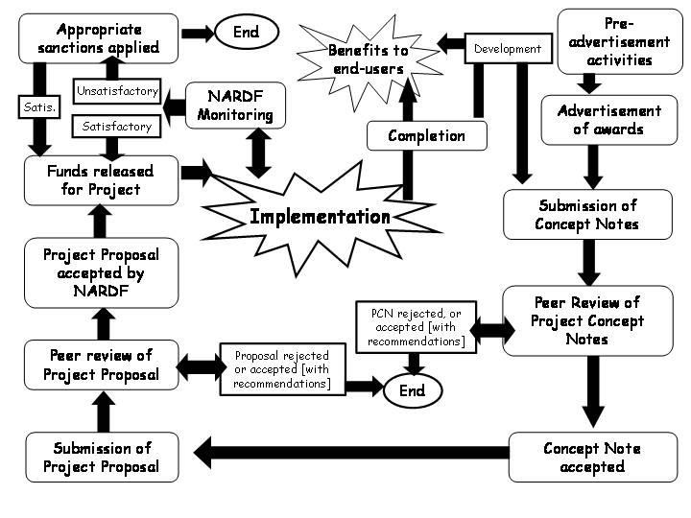
Figure 3: NARDF cycle of application, approval and implementation
- The Technical Sub Committee [TSC] has nine members, and is established by FMC under the Cabinet order of 10 December 2001. Seven members are appointed by the FMC on the basis of recommendations from a Selection Committee; two members are from the NARDF Secretariat, the Member Secretary of the FMC and the Senior Program Officer. The TSC elects its chairperson from its members. The Member Secretary of the TSC is the Senior Program Officer from the Secretariat. Criteria for membership of the TSC include:
a. An academic qualification of minimum Master's degree and ten years of experience in related field;
b. Relevant experience and technical expertise in one or more of the following areas: crops and horticulture, livestock and fisheries, social sciences, economics, development, communication, extension, biotechnology, natural resources, environment, agro- processing and post harvest technology and agro- forestry;
c. Familiarity in current agricultural research and development issues and Organizations in Nepal;
d. Not involved in NARDF funded project execution, individually or officially.
- The term of appointed TSC membership is a maximum of three years, but the FMC can terminate any such member any time in the ground of non- performance.
- The TSC can invite additional experts to address specific needs and issues when they arise.
- A TSC member can neither act as a peer reviewer nor can submit a proposal.
PANEL OF PEER REVIEWERS
- The FMC appoints the Panels of Peer Reviewers upon the recommendation of the TSC. The criteria to be a Peer Reviewer are as follows:
a. An academic qualification of minimum Master's degree and ten years of experience in related field,
b. Relevant experience and technical expertise in one or more of the following areas: crops [including industrial and horticultural crops], livestock and fisheries, social sciences, economics, development, communication, extension, biotechnology, natural resources, environment, agro- processing and post harvest technology and agro- forestry,
c. Familiarity in current agricultural research and development issues and organizations in Nepal,
d. Willing to work as a Peer Reviewer as expressed by submitting filled up prescribed form to NARDF secretariat,
e. Completed an orientation course designed and organized by NARDF for peer reviewer,
f. The term of a Peer Reviewer is continuous, provided the review work is satisfactory,
g. Ex-NARDF officer had completed one complete cycle of project selection process having a academic qualification of minimum Master's Degree and ten years of experience in related field.
CODE OF CONDUCT OF PEER REVIEWERS
- The PCN, FPP and TP are sent to the reviewers on the condition of anonymity. If a reviewer identifies the proponent, or the proponent approaches the reviewer, the reviewer should state the fact (as given in Peer Reviewers pro-forma in Annex 3, 4, and 5) and send the PCN, FPP and TP back to NARDF Secretariat without a peer review.
- If a PCN or FPP or TP is evaluated by a reviewer despite having identity disclosed, it is regarded as an offence. If sufficient evidence is available to conclude that the peer reviewer had identity of the proponent, the case will be taken to FMC for action. Such reviewers will be removed from the panel of peer reviewers.
- If it is found that a reviewer gets involved in any project granted by NARDF, evaluated by himself/herself, the FMC can take action to the reviewers by removing him from the project through instructing the Awardee. He/she will be disqualified (blacklisted) to be a peer reviewer and a proponent in future. Before such action taken, the FMC will give the reviewer a chance for clarification. If the Awardee does not oblige the instruction of the FMC, the project will be terminated.
- Peer Reviewers, submit the following to NARDF Secretariat:
  - An evaluation report of the PCN or FPP or TP (fully completed pro- forma as in Annex 3, 4, 5) in hard copy. The first part of the report will be confidential and retained by the NARDF and the second part, the recommendations, will be passed to the applicant.
  - The reviewed PCN or FPP or TP in hard copy.
- The PCN, FPP and TP are confidential property of the proponent till the project is awarded. The Peer Reviewer must not disclose them or use them other than for the purpose of the evaluation. If a violation of this code of conduct is found, the Reviewer will be removed from the panel of Reviewers.
- A Peer Reviewer is paid an honorarium for each PCN, FPP and TP reviewed completely (as per the Pro-forma in Annex 3,4,5) and timely (as specified in the letter of request). If a reviewer does not comply with this code of conduct, a deduction of 10 percent will be applicable to his/her honorarium.
- The size of the fund for each category of projects shall not exceed the following and matching grant is not applicable.
- Category 1 Projects – Up to 5 Million Rupees
- Category 2 Projects – Up to 3.5 Million Rupees
- Small Grant Projects – Up to 2 Million Rupees
- Thesis Grant for PhD Degree – Up to 0.2 Million Rupees
- Thesis Grant for Master Degree – Up to 0.1 Million Rupees
SIZE OF FUNDS AND MANAGEMENT
- After signing the agreement, the proponent will receive the funds as a grant over a maximum three year period. In the case of PhD thesis, the grant period would be maximum for five years and M.Sc. Thesis, the grant period would be maximum for three years.
- The funds should be managed according to the NARDF rules and guidelines for such grants.
- The NARDF Secretariat acts as the administrator of grants and monitors the use of funds and activities
MONITORING AND REPORTING
- The NARDF Secretariat sends the agreement document along with the FPP of each project to the concerned District/Regional Government office including departments for collaboration, coordination, monitoring and performance reporting.
- The NARDF Secretariat requires presenting annual technical and financial reports of each of the NARDF supported projects to the Fund Management Committee (FMC).
- To meet this requirement, the concerned M & E officer, NARDF Secretariat co- ordinates the technical monitoring of project activities, at the level of Activities to Output, on the basis of the logical framework in the proposal.
- Each Awardee is required to submit trimester [every four months], annual and Project completion (final technical and financial) reports according to the guidelines in Chapter- 9 and Annex-6, respectively.

